Designing a PDF Audio book using Python
In this code, a simple implementation of PDF Audio book is shown. PDF text is read to the user as audio using this code.

Introduction
It may be difficult to read stories or essays or other text, but audio reading
of the text is easy and does not take as much focus as reading requires.An audio book is a recording of a book or other work being read out loud.
If we have a pdf version of our book, we do not need to purchase an audio book subscription.
In this project, I have implemented a simple PDF to audio converter. This code scans the PDF page(s) and reads it to the user, using audio.
While this project is good for simple text reading, it does not perform good if a scientific paper with equations is given to it because equations are not supported to be read in pyttsx3 OCR library which we used to convert image to text.

Project Flow
Here is the project flow diagram:

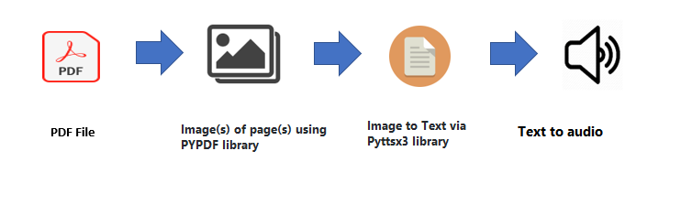

Installation:
Python has an ocean of libraries which serve different purposes. To create an audio book, we will need two libraries (pyttsx3, PyPDF2).

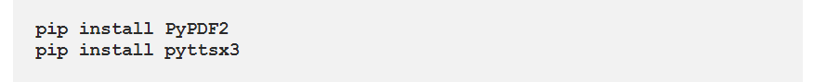

1) Read the PDF file:
Python has library PyPDF2 which is built as a PDF toolkit. It allows pdf manipulation in memory. This library is capable of:
- extracting document information, such as title, author, etc
- splitting documents by page
- merging documents by page
- cropping pages
- encrypting and decrypting PDF files and many more!

This library is used to split the pdf file page by page, read each page's text, and send the text to the next layer/step.

2) Initialize Speaker:
Python has a library pyttsx3, that is capable to convert text-to-speech offline. Text that we are reading from a pdf file using the pypdf2 library is fed as an input to the text-to-speech engine.

Play the Audio book:
Using thePyPDF2 implementation to extract the text from the pdf file page by page.Loop through each page, by reading the text and feeding it to the pyttsx3 speaker engine. The text from PDF page will be read out loud.Loop the process in the pdf file for every page
and stop the pyttsx3 speaker engine as the last one.

Features:
- Fully OFFLINE text to speech conversion
- Choose among different voices installed in your system
- Control Speed/rate of Speech
- Tweak volume
- Save the speech audio as file

Conclusion
The code has been shown to do very well in reading basic PDF text files, but
if calculations are involved in the text, then the reader is unable to interpret the equations
Properly.The code is therefore suitable for plain text, but not for science articles as it would fumble the calculation interpreting. The text, however will read just fine.
Hence, the code is good for simple text but not for scientific papers as it will fumble reading the equations. However, text will be read just fine.

Future Work
This code can be expanded to create a program for book reading or combined with machine learning to create a really entertaining story reader with immersive sounds depending on the
situation shown in the text.

References:
[1] PyPDF2 documentation: https://pypi.org/project/PyPDF2/
[2] pyttsx3 documentation: https://pyttsx3.readthedocs.io/en/latest/

